Session 4 - 1

import java.io.*;

public class Solution {

public static int palindromeIndex(String s) {
int left = 0;
int right = s.length() - 1;

while (left < right) {
if (s.charAt(left) != s.charAt(right)) {
// If skipping 'left' makes the rest a palindrome, remove 'left'
if (isPalindrome(s, left + 1, right)) {
return left;
}
// Otherwise, the only option is to remove 'right'
return right;
}
left++;
right--;
}

// Already a palindrome
return -1;
}

// Helper method to check if a substring is a valid palindrome
private static boolean isPalindrome(String s, int left, int right) {
while (left < right) {
if (s.charAt(left) != s.charAt(right)) {
return false;
}
left++;
right--;
}
return true;
}

public static void main(String[] args) throws IOException {
BufferedReader bufferedReader = new BufferedReader(new InputStreamReader(System.in));

// Read number of queries
int q = Integer.parseInt(bufferedReader.readLine().trim());

for (int i = 0; i < q; i++) {
String s = bufferedReader.readLine().trim();
int result = palindromeIndex(s);
System.out.println(result);
}

bufferedReader.close();
}
}
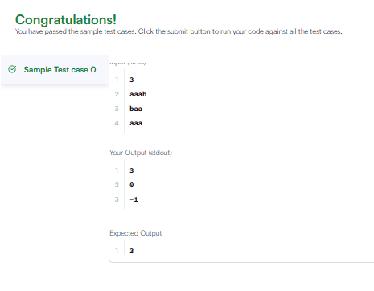

Session 4 - 2

public class Solution {
public int strStr(String haystack, String needle) {
int hLen = haystack.length();
int nLen = needle.length();

// Edge case: needle cannot be longer than haystack
if (nLen > hLen) {
return -1;
}

// Scan haystack up to the last possible starting point
for (int i = 0; i <= hLen - nLen; i++) {
int j = 0;

// Check if characters match needle
while (j < nLen && haystack.charAt(i + j) == needle.charAt(j)) {
j++;
}

// If full needle is matched, return starting index
if (j == nLen) {
return i;
}
}

return -1;
}
}
